**My Voice** Child: Adult: Date:

In school I like to:

Resources / equipment that helps me:

How happy are you at school? 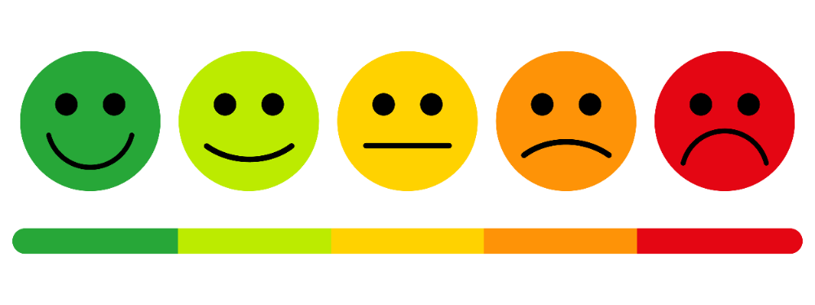

Why?

I am happy when:

I am not happy in school when:

My trusted adults in school are:

Other things I’d like you to know:

Things I enjoy out of school

(activities & clubs):

At home I like to:

My favourite place is:

My favourite phrase is:

Things that could be better in school:

When I am older I would like to be / my hopes & dreams:

My achievements, successes & certificates  
(in and out of school):

Things that would make me happier are:

My   
favourite animal:

I like to communicate by: talking writing drawing pictures ____________________

I am good at / my strengths:

A proud moment is:

I would like to get better at:

I like to talk about:

My   
favourite colour:

is

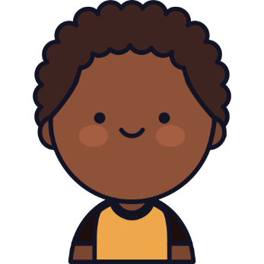

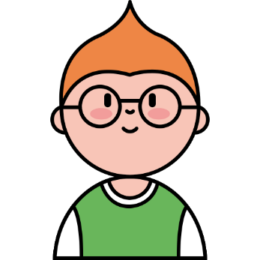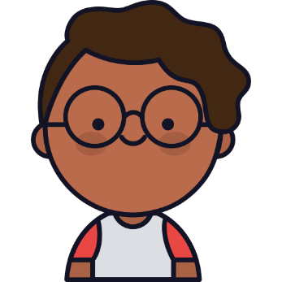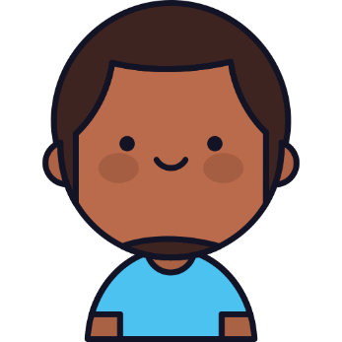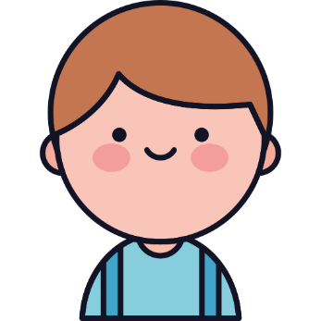



Faces from Flat icon

[Kawaii People Icon Pack | Outline Color | 25 .SVG Icons](https://www.flaticon.com/packs/kawaii-people)